Etwall Primary School Parent, Teacher and Friends Association

**NEWSLETTER SEPTEMBER 2019**

We are looking forward to welcoming everyone at our general PTFA meeting on

**Wednesday 25th September, 6.30pm at the Blenheim House**.

If you have any questions about the PTFA please do have a chat with one of our committee members. Our information can be found on the notice board outside the main school gates.

**Thank you** for all the support with the events last half term. The Summer Disco, Summer Fair and Music Festival were all a great successes!

**Ways you can help with fundraising:**

 

* Does your work place support match funding?
* Recycle your clothing in the green clothing bank situated on the car park next to the school drive.



The weather was wonderful and lots of you came to support this event! Thank you.

Many thanks to Val and the team for your organisation.

It was an amazing success raising **£1410**!

Come next year and see if you can beat the goalie!

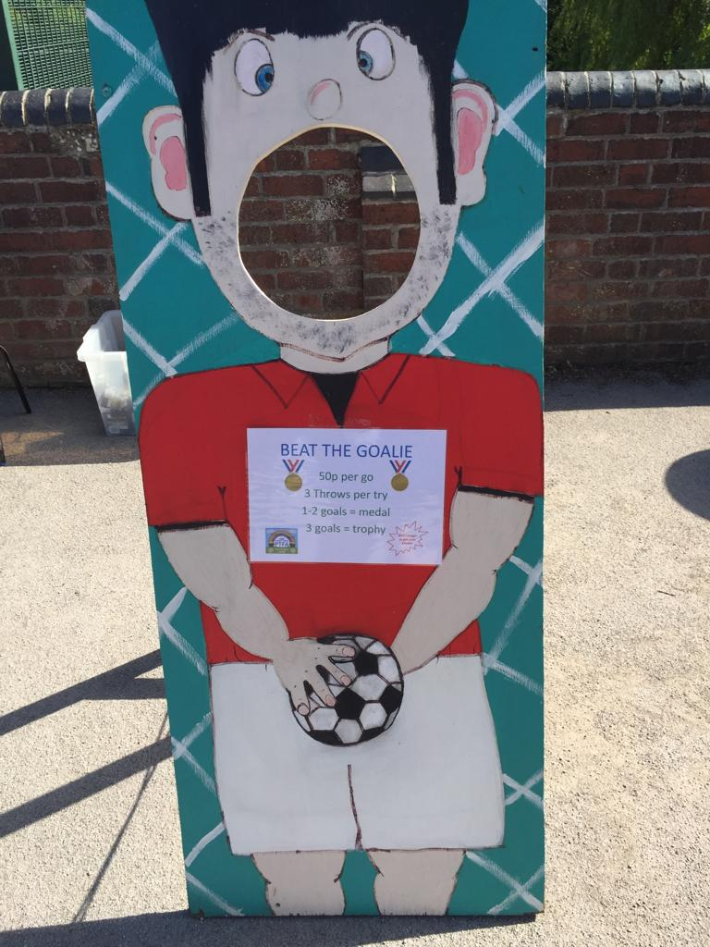



**FILM NIGHT**

Monday 7TH October

**RECYCLING** **DAY**

Friday 25TH October

**CHRISTMAS CARD DESIGNS RETURNED TO SCHOOL**

Tuesday 22nd October

**FIREWORKS**

Friday 8TH November

**NEXT PTFA MEETING**

Wednesday 20th November

**SCHOOL DISCO**

Thursday 28TH November

**CHRISTMAS EVENTS**

**CHRISTMAS HAMPER DRESS DOWN DAY**

Friday 6th December

**SECRET SANTA**

Friday 6th December

**CHRISTMAS HAMPER RAFFLE**

Thursday 12th December



The Music Festival was a great day full of live bands, tombola, sweet stalls, bouncy castles, candy floss and much more!

Well done to Lu and Gill and the rest of the team for organising the event alongside Etwall Cricket Club. Thank you!

We raised a whopping **£1400**!