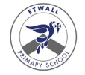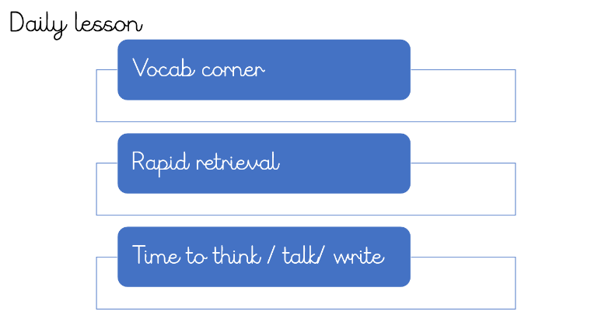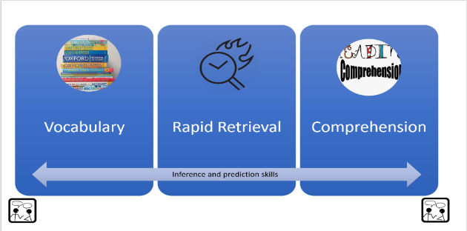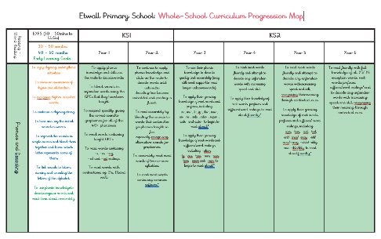

**Implementation: lesson sequence (daily)**

To reduce cognitive overload, learners follow a pattern to each lesson so that they know what is expected. Weighting of each element varies, depending on the text and the analysis of learners’ needs.

**Implementation: lesson sequence (weekly)**

Every skill will be covered, using partner talk and routinely practicing fluency, prediction and inference to achieve lesson outcomes.

Scaffolding for readers will be provided, with prompts and support for learners to achieve the mixed-age outcomes.

High quality texts will ensure the vocabulary learnt encourages high level language in writing.

**Implementation: Planning**

In EYFS and Y1, reading planning is provided as determined by stage of learning within the Little Wandle scheme. Opportunities to enhance cultural capital are planned into the continuous and enhanced provision.

Y2 to Y6: Reading planning informs and is informed by writing planning. Opportunities for cross-over are seized with enthusiasm.

**Implementation: Scheme**

In EYFS and Year 1 children learn to read with Little Wandle Letters and Sounds Revised. Within this programme, Reading Practice (RP) sessions ensure that new GPCs are applied in a meaningful way through decoding, prosody and comprehension teaching and learning.

Reading Progression from Y2 to Y6 is informed by the EPS reading progression map. Fred’s Teaching provides the content for our lessons.

**Reading at Etwall Primary School**

**Intent Statement**

At Etwall Primary School, we intend that every child learns to read by the end of Key Stage 1. We aim to create fluent readers who monitor and self-correct, understand what they read, make connections between their reading material and read for enjoyment and pleasure. We are committed to helping children find enjoyment in reading and to appreciate how books can offer a window to other worlds, meet amazing characters and learn about the world they live in. Our books are carefully chosen with important and diverse themes that help to build on pupils’ cultural capital and knowledge.

Our intention is that learners will breathe in the language they need to breathe out the stories they will tell.

**Implementation: How Groups are Supported (SEND, GDS, PP, disadvantaged, EAL)**

• Children with additional needs are given targeted and bespoke support.

• Those children for whom phonics hasn’t worked (or isn’t working) take part in an intervention with fully trained teaching staff.

• Formative and summative assessments inform next steps for highlighted individuals and groups.

• Quality first teaching strategies to support all learners.

• Use of Digital Learning to enhance the writing process through research, editing and

publishing.

• Formative and summative assessments inform next steps for highlighted individuals and groups.

• Quality-first teaching strategies to support all learners.

• Lowest 20% are identified following each assessment window and strategies to support are identified.

• Bi-Weekly use libraries.

• Children can change their banded books whenever they want.

• PP children are bought books appropriate to their needs

**Implementation: T&L / Pedagogies**

In EYFS and Year 1, RP sessions are grounded in the learning of the Little Wandle scheme and focus on decoding, prosody and comprehension within small-group, adult-led sessions. In Year 1, the children are exposed to NTS Assessment-style questions during comprehension RP sessions towards the Spring and Summer terms.

Whole class reading is introduced in Year 2 and is continued across KS2. This approach is based on the work of Doug Lemov and the Fred’s Teaching shared reading sessions improve children's ability to understand challenging texts through carefully selected novel studies as well as focusing on the key reading skills and strategies required to be confident readers. Linked texts in lessons include poetry, picture books, non-fiction, modern and classic novels, inspiring biographies, song lyrics and famous authors.

Reading fluency is taught as part of whole class reading lessons using echo, choral, paired and repeated strategies.

**Implementation: Resources**

• Little Wandle Letters and Sounds Revised – fully comprehensive scheme with resources provided.

• Big Cat Phonics for Little Wandle Letters and Sounds Revised: fully decodable books matched to LW progression, supporting all phases for FS2 and Y1.

• Non-matched phonics books for Year 2 – colour coded (from Pink to Lime).

• Year 3 to Year 6: Banded reading books from a range of reading schemes and also banded books from non-reading schemes. Advice from consultant text supplier.

• NFER Reading Assessments.; Star Reader tests

• Reading for Pleasure strategies.

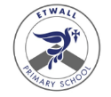

**Implementation: Curriculum links**

The books we choose are linked to our topics in school with the intention of developing children’s background knowledge and vocabulary acquisition. If links to topics are tenuous, other factors may override this choice, including knowledge of literature.

We intend to immerse learners in a genre and this can be via topic - based literature as well as different media types.

**Implementation: Curriculum links**

The books we choose are linked to our topics in school with the intention of developing children’s background knowledge and vocabulary acquisition. If links to topics are tenuous, other factors may override this choice, including knowledge of literature.

We intend to immerse learners in a genre and this can be via topic - based literature as well as different media types.

**Implementation: Feedback**

* Feedback given during lesson input through teaching of skills.
* Fluency developed through a ranged of strategies where children can receive immediate feedback and support from their teachers and peers including explicit modelling of prosody.
* Live-marking ensures that children are given the opportunity to understand their learning in the moment.

**Implementation: Environment**

* Our reading environment should help to promote ‘Reading for Pleasure’ culture.
* Reading area clearly visible when standing at any entrance doors to the classroom.
* Some / mostly forward-facing books (depending on key stage)
* Books carefully selected
* No overcrowding of books.
* Books at different heights.
* Picture books in every classroom.
* Topic books clearly displayed
* ‘Books We Have Read’ display, encouraging chn to make connections.
* ‘We are reading’ displayed on English working wall
* library maintained by Literacy committee/ Reading ambassadors
* Library used regularly and opportunities to exchange books regularly provided

**Impact: Assessment**

EYFS and Year 1: Six-weekly LW assessments inform next steps and AfL occurs during each RP session.

Y2 to Y6: Star reader assessments are used termly for summative data; NFER tests for summative data; data analysis undertaken.

AfL: occurs in any lesson where reading takes place e.g. using retrieval skills when reading a worded problem in maths.

End of Key Stage (Y2 and Y6) SATs tests provide nationally published data.

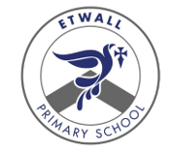

Etwall Primary School Reading Intent, implement and impact statements

(December 2022)

**Impact: Monitoring**

* Lesson slide reviews – does what is recorded on the 3-week writing unit match what is on individual lesson slides?
* Book-looks
* Learning walks and drop-ins
* Pupil voice
* Summative assessment outcomes (data from NFER analysis or SATs)
* Pupil Progress narratives

**Impact: Evidence**

Reading for Pleasure – children at Etwall enjoy and look forward to opportunities to celebrate their love for reading.

A celebration of books can be seen and felt throughout the school environment.

The importance of high-quality, diverse and impactful texts are woven through our topics.

Summative assessments show an above- standard of attainment compared to local or national.