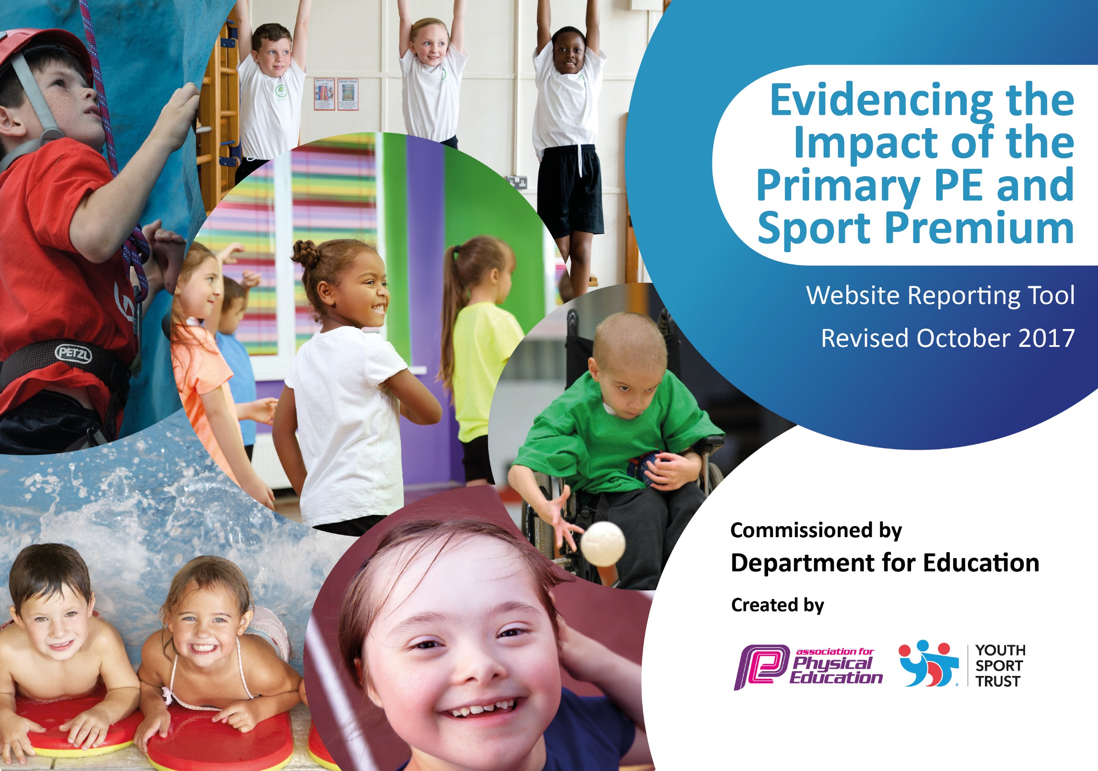

Schools must use the funding to make additional and sustainable improvements to the quality of PE and sport they offer. This means that you should use the Primary PE and Sport Premium to:

- develop or add to the PE and sport activities that your school already offers
- build capacity and capability within the school to ensure that improvements made now will benefit pupils joining the school in future years

Please visit gov.uk for the revised DfE guidance including the 5 key indicators across which schools should demonstrate an improvement. This document will help you to review your provision and to report your spend. DfE encourages schools to use this template as an effective way of meeting the reporting requirements of the Primary PE and Sport Premium.

We recommend you start by reflecting on the impact of current provision and reviewing the previous spend.
Under the Ofsted Schools Inspection Framework, inspectors will assess how effectively leaders use
the Primary PE and Sport Premium and measure its impact on outcomes for pupils, and how effectively governors hold them to account
for this.

Schools are required to publish details of how they spend this funding as well as on the impact it has on pupils’ PE
and sport participation and attainment.
We recommend regularly updating the table and
publishing it on your website as evidence
of your ongoing review into how you are using the money
to secure maximum, sustainable impact. To see an example of how to complete the table please click HERE.

Support for review and reflection - considering the 5 key indicators from DfE, what development needs are a priority for your setting and your students now and why? Use the space below to reflect on previous spend, identify current need and priorities for the future.

Key achievements to date: | Areas for further improvement and baseline evidence of need:
- Engaging children in regular physical activity has been a big area for EPS. A wide variety of lunchtime sessions were provided, including specific opportunities for different key stages and genders. We have improved our provision by ensuring more opportunities for Key Stage 1. Further to that, we have enhanced our provision through a carousel of swimming for all year groups and Forest Schools provision as a PE unit for all year groups.  - We have begun to get back into competitive sports, post lockdown, through SDASP and Progressive Sports.  - All staff have been given CPD in how to teach Real PE  - After school clubs continue to offer a wide range of different activities such as glow in the dark dodgeball. The long-term PE plan has been rewritten to reflect the schools new approach to the curriculum | - Work needs to be done on the sports displays around school and mention of sporting achievements in assemblies to increase the profile of PE still further.  - Further CPD on Real Dance/Gymnastics to follow in 2022/23  - Continue to promote the importance of competitive sport and look for more opportunities to get children of all ages involved.  - Further refinement of the long-term plan to adopt a cultural capital approach encompassing things like maypole dancing

Meeting national curriculum requirements for swimming and water safety | Please complete all of the below:
What percentage of your Year 6 pupils could swim competently, confidently and proficiently over a distance of at least 25 metres when they left your primary school at the end of last academic year? | 2020-21: Figures unavailable due to Covid-19  2021-22: 85%
What percentage of your Year 6 pupils could use a range of strokes effectively [for example, front crawl, backstroke and breaststroke] when they left your primary school at the end of last academic year? | 2020-21: Figures unavailable due to Covid-19  2021-22: 96%
What percentage of your Year 6 pupils could perform safe self-rescue in different water-based situations when they left your primary school at the end of last academic year? | 2020-21: Figures unavailable due to Covid-19  2021-22: 96%
Schools can choose to use the Primary PE and Sport Premium to provide additional provision for swimming but this must be for activity over and above the national curriculum requirements. Have you used it in this way? | Yes

Action Plan and Budget Tracking
Capture your intended annual spend against the 5 key indicators. Clarify the success criteria and evidence of impact that you intend to measure to evaluate for students today and for the future.

Financial Year: 2021/22 | Total fund allocated: £18,580 (supplemented with £8978) = £27,558 | Date Updated: 15-10-21
Key indicator 1: The engagement of all pupils in regular physical activity – Chief Medical Officer guidelines recommend that primary school children undertake at least 30 minutes of physical activity a day in school |  |  |  | Percentage of total allocation:
 |  |  |  | 18.8%
School focus with clarity on intended impact on pupils: | Actions to achieve: | Funding allocated: | Evidence and impact: | Sustainability and suggested next steps:
- Continue to develop lunchtime activity clubs to get a wider range of pupils participating in regular activity  - Continue to promote after school activities to increase participation in a wider range of activities  - Look into the possibility of introducing a gifted and talented and/or SEND sports session during golden time on Fridays to develop sports provision for specific groups  - Reintroduction of Real PE and associated programmes post-pandemic | - Maintain dialogue with Progressive Sports and increase their role in school activities through a pre-planned calendar of activities.  - Look into the possibility of taster days in order to promote the forthcoming term’s activities – Gaelic Football, Tag Rugby etc  - Discuss provision with sports activity providers  - Sign up to Real PE/Create Development | - 190hrs @ 5x1hr per wk for 38 wks =  £4,174  - 7.5hrs @ 2x0.75hrs (1.5hrs per class) = £0  - 17.5hrs @ 0.5hrs per wk for 38 wks =  £420  - £594  - Total: £5,188 | - In excess of 50 children have participated in lunchtime clubs across all Key Stages.  - n/a children participating in taster activities  - Golden time no longer timetabled. Look to alternatives in 2022/23  - All children across school are doing 2 PE sessions a week, directly linked to Create Development through PE LTP | - Aim to increase numbers through better ‘marketing’ of activities e.g. letters home etc. and increased participation from EYFS.  Aim to increase take up of ASCs through taster days  - Provide a core group of ‘go to’ athletes for competitive events and broaden the offering provided for SEND pupils  - Further utilise the assessment tools within Real PE etc.

Key indicator 2: The profile of PE and sport being raised across the school as a tool for whole school improvement |  |  |  | Percentage of total allocation:
 |  |  |  | 0.7%
School focus with clarity on intended impact on pupils: | Actions to achieve: | Funding allocated: | Evidence and impact: | Sustainability and suggested next steps:
- Celebration assembly every week to ensure the whole school is aware of the importance of PE and Sport and to encourage all pupils to aspire to being involved in the assemblies.  - Use of Class Dojo to promote sporting success both inside and out of school  - Extra notice boards in hall to raise the profile of PE and Sport | - Achievements celebrated in assembly (match results & notable achievements in lessons etc.)  - Achievements shared with the wider school community  - General sprucing up of PE displays and noticeboards | - £0  - £0  - £200  - Total: £200 | - Examples of pupils having had their achievements recognized in an assembly are the swimming team, local U7s football team and several children with karate belts  - All pupils representing the school in competitions have been recognized on Class Dojo  - Further work required to promote sport via noticeboards etc. | - Continued recognition of sporting achievements within school and externally  - Continued recognition of sporting achievements within school and externally  - Continued improvement of information available on noticeboards

Key indicator 3: Increased confidence, knowledge and skills of all staff in teaching PE and sport |  |  |  | Percentage of total allocation:
 |  |  |  | 2.9%
School focus with clarity on intended  impact on pupils: | Actions to achieve: | Funding  allocated: | Evidence and impact: | Sustainability and suggested  next steps:
- Continued usage of the DCC CPD package to develop staff confidence and quality of delivery to pupils  - Cover for CPD to allow staff to attend training | - Ensure all staff are a) aware and b) actively involved in CPD  - Ensure that cover is provided to allow staff to attend training courses | - £420  - 22hrs @ 2hrsx11 staff = £393  - Total: £813 | - All staff attended CPD on Real PE in the Spring term  - Cover is arranged appropriately to allow staff to attend required training | - Continued recognition of the need to develop staff in order to build confidence, knowledge and skills  - Continued use of Sports Funding to free up staff and improve sustainability of PE provision

Key indicator 4: Broader experience of a range of sports and activities offered to all pupils |  |  |  | Percentage of total allocation:
 |  |  |  | 66.9%
School focus with clarity on intended  impact on pupils: | Actions to achieve: | Funding  allocated: | Evidence and impact: | Sustainability and suggested  next steps:
- See Key indicator 1 for information on lunchtime and ASC activities  - Develop use of mini leaders to allow peer-led engagement in sports  - Outdoor Learning Lead to utilise Forest Schools programme to engage children across KS1 and KS2 in OAA on a regular basis  - Continue to part fund Outdoor Nurture activities to engage children with social and emotional issues in OAA activities  - Provide additional swimming opportunities for Y3 using school pool and swimming instructor  - Ensure take up of additional opportunities such as Balanceability, Bikeability, Five 60 etc | - See Key indicator 1 for information on lunchtime and ASC activities  - Liaise with South Derbyshire ASP to provide training  - Link Performance Management targets of Outdoor Learning Lead to this key indicator  - Liaise with SEND Lead to maintain current provision  - Ensure quality of provision for Y3 based on Key Steps Swimming Scheme  - Maintain dialogue with SDASP to ensure that we are signed up to additional opportunities | - See Key indicator 1 for info on lunch/ASCs  - £100  - 2 x 3hrs x 38wks = £3,420  - £150 x 37 weeks (50% overall cost) = £2,775  - £11,555  - £600  - Total: £18,450 | - See Key indicator 1 for information on lunchtime and ASC activities  - Still on hold due to COVID restrictions and the roll out of previous training  - All KS1 classes now have Forest Schools as part of the OAA offering in PE.  - 18 children receiving continued provision of outdoor nurture having a positive impact on those with social and emotional difficulties  - Pupils in all year groups (not just Y3) have swum for a term this year as part of COVID catch up  - xxx children have undertaken additional opportunities, broken down as follows:  KS1 Balanceability – 36  Y5 Bikeability – 48  Y6 Bikeability - 45 | - See Key indicator 1 for information on lunchtime and ASC activities  - Training completed in September to provide full opportunity to use  - KS1 and KS2 Forest Schools Leads to liaise with each other on a high quality FS programme.  - Continued monitoring of children undertaking the outdoor nurture programme to evaluate impact  - Ensure that progress is made and recorded, with next steps put in place for KS2  - Continue to liaise with SDASP to underline the importance of the additional offering

Key indicator 5: Increased participation in competitive sport |  |  |  | Percentage of total allocation:
 |  |  |  | 10.5%
School focus with clarity on intended  impact on pupils: | Actions to achieve: | Funding  allocated: | Evidence and impact: | Sustainability and suggested  next steps:
- Continue to sign up to the South Derbyshire ASP affiliation package to provide a wide variety of competitive opportunities for all year groups  - Continue to look for other opportunities to promote competitive sport such as DCLFC tournaments, Brownlee Foundation triathlon, National Swimming Championships etc  - Staff cover for sporting events | - Sign up to package when documentation arrives  - Maintain links with local sporting organisations in order to keep abreast of any forthcoming competitions  - Ensure HLTA cover for any upcoming events | - £1,987  - £100  - £820  - Total: £2,907 | - Over 50 children have participated in competitive sport, including those with SEND.  - External sporting competitions are still thin on the ground post-COVID. This is a focus for next year.  - Continued participation at SDASP events. | - Maintain dialogue with SDASP in order to ensure appropriate provision for pupils  - Continue to develop links with external providers  - Continue liaison with SDASP to ensure quality events are participated in

Anticipated Wider Impact as a Result of the Above
ü Pupils are more active in PE lessons - take part without stopping to rest
ü Standards achieved in PE NC are improving with over 95% achieving end. of KS attainment target
ü Attitudes to learning improved - better concentration in lessons
ü SATs results improved
ü Pupils are very proud to be involved in assembles/photos on notice boards etc. which is impacting on confidence and self esteem
ü Increased pupil numbers attending clubs in the community which is complimenting activities in school and in the curriculum
ü Increased self-esteem/confidence are having an impact on learning across the curriculum
ü Skills, knowledge and understanding of pupils are increased significantly
ü Pupils really enjoy PE and Sport, are very keen to take part and demonstrate a real desire to learn and improve
ü Behaviour has improved particularly at lunch times and this has led to improved learning in the afternoons
ü Very few instances of pupils not bring kit to school and as a result progress and achievement in curriculum PE is good
ü More pupils say they enjoy PE and Sport and want to get involved in more activities
ü Greater proficiency of KS2 swimmers
ü Improved standards in invasion games in curriculum time
ü More girls are keen to take part with a noticeable difference in attitudes to PE and sport

