EYFS Long Term Plan 2022-2023

 |  | Autumn 1 | Autumn 2 | Spring 1 | Spring 2 | Summer 1 | Summer 2
 |  | 1st Sept-21st Oct | 31st Oct-22nd Dec | 9th Jan-17th Feb | 27th Feb-31st Mar | 17th Apr-26th May | 5th Jun-21st Jul
 |  | 7 weeks 2 days | 8 weeks | 6 weeks | 6 weeks | 6 weeks | 7 weeks
 | Theme | Baseline  All about me  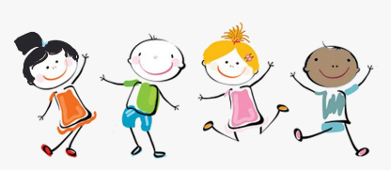 | Colour and Light  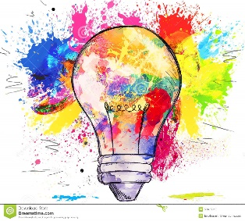 | Terrific Tales  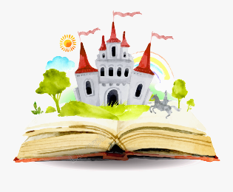 | Superheroes  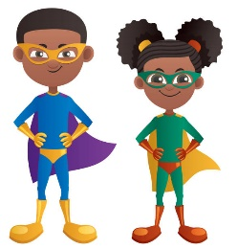 | Come outside  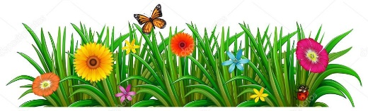 | Fun at the seaside/Pirates  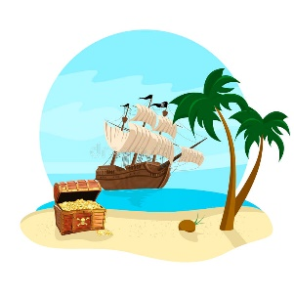
 |  | - Starting school  - My new class  - New beginnings  - What am I good at?  - How have I changed?  - My family | - Christmas lists  - Letters to Santa  - The nativity  - Colour mixing  - Light/shadow play  - Christmas around the world (using the map to compare how different people celebrate) | - Traditional tales  - Library visit | - People who help us  - Careers  - Staying healthy | - Plants & flowers  - Life cycles  - Minibeasts  - Habitats  - Weather/ season  - Does the moon shine?  - Planting seeds  - Make a sculpture: Andy Goldsworthy  - Reduce, reuse & recycle | - Map work- find the treasure  - Under the sea  - Where in the world shall we go?  - Send me a postcard  - Marine life  - Fossils- Mary Anning  - Seaside’s in the past.  - Compare: Now and then  - Seaside art
 | Key Events | - Harvest  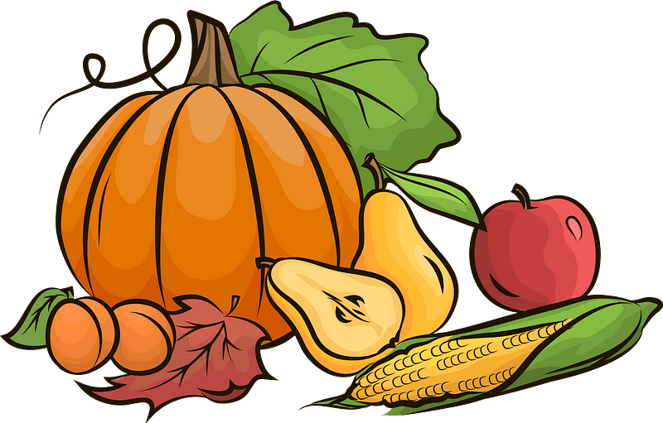 | - Guy Fawkes (5th Nov)  - Remembrance Sunday (12th Nov)  - Diwali (12th Nov)  - Children in Need (Nov)  - Anti-bullying week (Nov)  - St Andrew’s Day (30th Nov)  - Hannukah (7th Dec)  - Christmas (25th Dec)  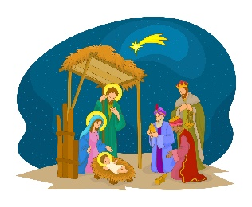 | - Epiphany (6th Jan)  - Chinese New Year (22nd Jan)  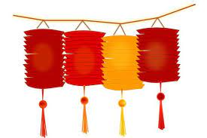 | - Pancake Day (21st Feb)  - St David’s Day (1st Mar)  - World Book Day (2nd Mar)  - Holi (8th Mar)  - St Patricks Day (17th Mar)  - Ramadan (22nd Mar)  - Easter (9th Apr) | - St George’s Day (23rd Apr)  - World Bee Day (20th May)  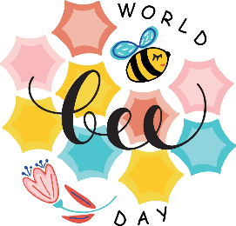 | - School Trip  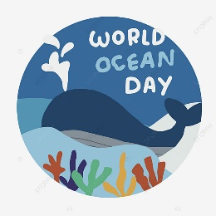  - World Oceans Day (8th June)
 | WOW moments | - Receiving a mouse  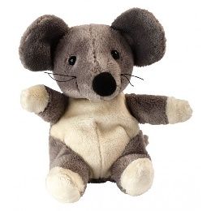  - Walk around our school. | - Stories by fireside  - Food tasting- Diwali  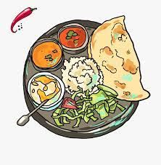  - Fundraising | - Food tasting- Chinese  - Library visit  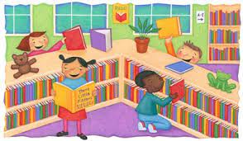 | - Decorating pancakes  - Visits from real life heroes.  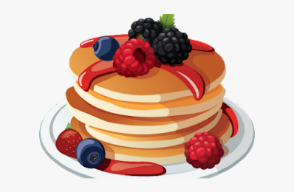 | - Nature walks  - Growing plants  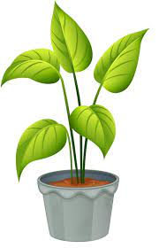 | - Singing sea shanties  - Fossil hunting  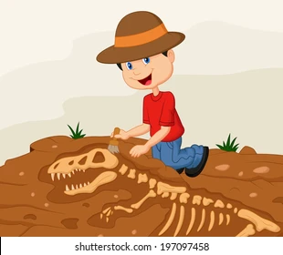  - School trip
C&L  Literacy | Key Texts | - Our class is a family  - When a dragon goes to school | - Guy Fawkes story  - Diwali story  - Nativity story | - Little Red Riding Hood  - Three Little Pigs  - Goldilocks  - Forgotten Fairy tales of Brave and Brilliant Girls  - Once upon a time | - The jolly postman  - Ten currant buns  - Supertato | - Gruffalo  - We’re going on a bear hunt  - Omar, the bees and me  - Jack and the beanstalk  - Some bugs | - The Big Book of the Blue  - The sea below my toes  - The odd fish  - Leo and the octopus  - Meet the oceans  - Lighthouse keepers’ lunch  - Snail and the whale  - The whale who wanted more  - Sharing a shell  - Octopus Shocktopus  - Somebody Swallowed Stanley  - Life Size Ocean Animals  - Ocean Meets Sky  - The Adventures of Scout Stop Dropping Litter  - Sea  - The Tale of a Toothbrush  - There was an o mermaid who swallowed a shark
 | Wider curriculum books | PSED  - Thelma the Unicorn  - I don’t want curly hair  - What makes me, ME!  - Who you were made to be.  - Incredible you | PSED  - The smile (the power of kindness)  - Bad apple  - The bad seed  EAD  - Mixed | PSED  - I am able to shine  - The pout-pout fish and the worry worry whale (anxiety)  - The way I feel  - My mouth is a volcano  - The most magnificent thing  RE  - Grace is enough | PSED  RE  Maths  - One is a snail ten is a crab | PSED  - The last tiger  - The life of a little cardboard box  - The life of a little plastic bottle.  - What a waste  RE  - Creation story (Christian and Islamic) | PSED  - I talk like a river  Topic  - Martha maps it out  - Big picture Atlas  - Map my area  - The planet in a pickle jar  - The last tree  - Clean up!  - Little Turtle and the Sea  - Turtle Rescue  - Dear Earth  - Dave and Greta make the world better.
Phonics | Phase | Phase 2 | Phase 2 | Phase 3 | Phase 3 | Phase 4 | Phase 4
 | Graphemes | s, a, t, p, i, n, m, d, g, o, c, k, ck, e, u, r, h, b, f, l | ff, ll, ss, j, v, w, x, y, z, zz, qu, ch, sh, th, ng, nk | ai, ee, igh, oa, oo, oo, ar, or, ur, ow, oi, ear, air, er | Reviewing Phase 3 | Applying phonics knowledge | Applying phonics knowledge
 | Tricky Words | is, I, the | as, and, has, his, her, go, no, to, into, she, he, of, we, me, be | was, you, they, my, by, all, are, sure, pure | No new tricky words. Review all taught so far and secure spelling. | said, so, have, like, some, come, love, do, were, here, little, says, there, when, what, one, out, today | No new tricky words. Review all taught so far and secure spelling.
Numeracy |  | Getting to know you  Just like me! | It’s me 1, 2, 3!  Light & dark | Alive in 5!  Growing 6,7,8 | Growing 6,7,8  Building 9 & 10 | To 20 and beyond  First, then, now | Find my pattern  On the move
Mastering Number |  | Weeks 1-5 | Weeks 6-10 | Weeks 11-15 | Weeks 16-20 | Weeks 20-25 | Weeks 25-30
UW | RE | 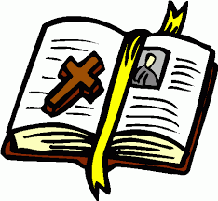  F1 What stories are special and why? | 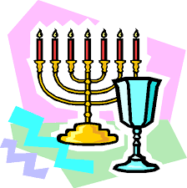  F4 Which times are special and why? | F2 Which people are special and why?  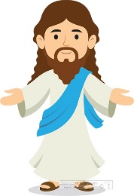 | 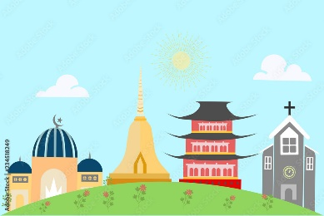  F3 Which places are special and why? | F6 What is special about our world?  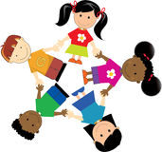 | F5 Where do we belong?
 | History | - Grandparents and families  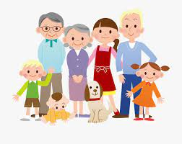  - Personal timeline |  |  |  |  | - Fossils- Mary Anning  - Seaside’s in the past.  - Compare: Now and then  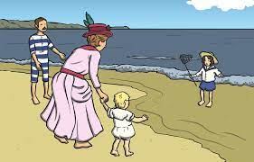
 | Geography |  | 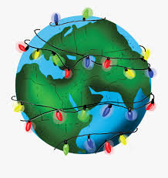  Comparing how different people celebrate Christmas |  |  |  | 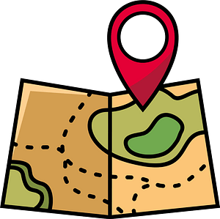  Maps
 | Science |  | 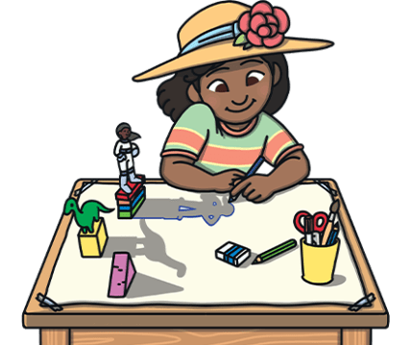  Exploring colour, light, darkness and shadows |  | 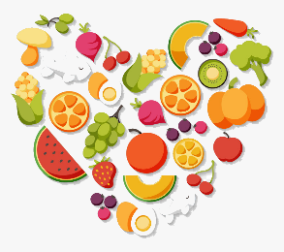  Staying healthy | 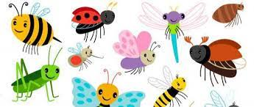  Habitats, minibeasts, life cycles
PSED | PSHE | Being Me | Bullying Matters | Exploring Emotions | Being healthy | Being Responsible | Difference and Diversity
PD | PE | Fundamentals  Balancing, running, jumping, changing direction, hopping and travelling  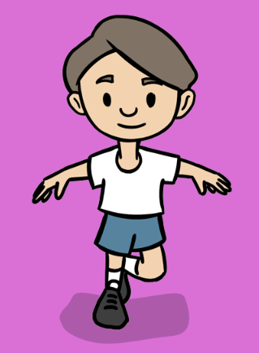 | Introduction to PE  Moving safely, running, jumping, throwing, catching and following a path  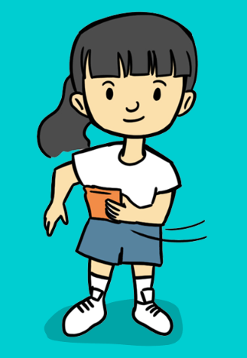 | Dance  Travelling, copying & performing actions and co-ordination  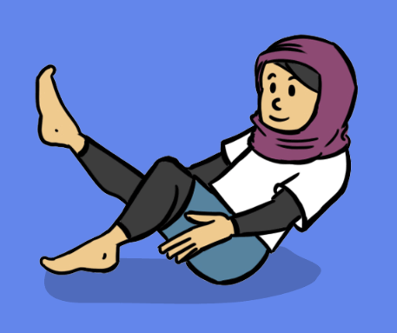 | Gymnastics  Shapes, balances, jumps, rocking, rolling and travelling  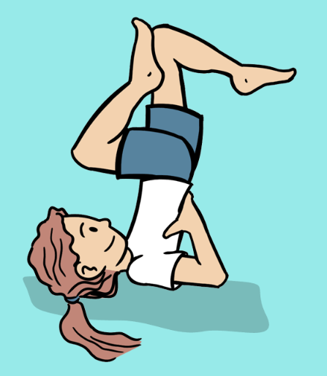 | Ball Skills  Rolling a ball, stopping a rolling ball, throwing at a target, bouncing a ball, dribbling a ball with feet and kicking a ball  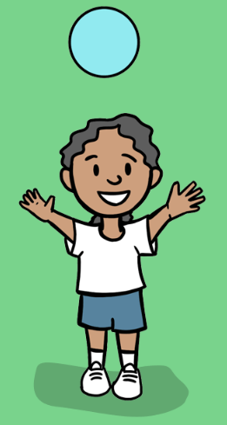 | Games  Running, balancing, changing direction, striking a ball and throwing  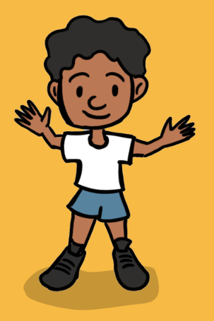
EAD | Art & design | 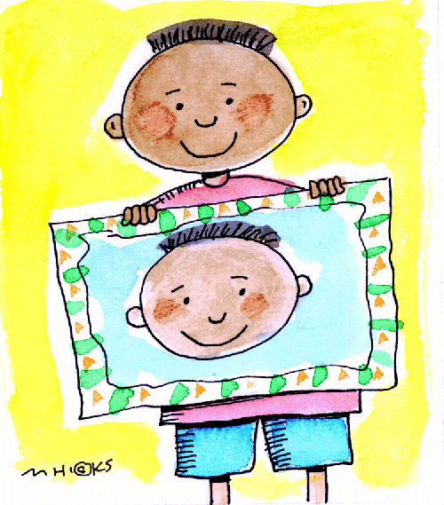  Self portraits | Diva lamps  Bonfire pictures  Colour mixing  Poppy Paintings  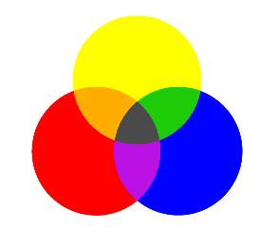  Christmas Cards | Painting and collage | Finger puppets and junk modelling | Andy Goldsworthy- sculptures and natural art  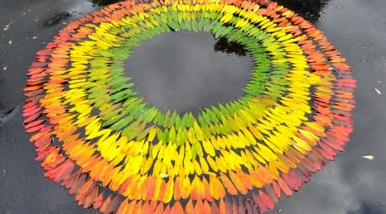  Observational drawing | Recycled art/ construction  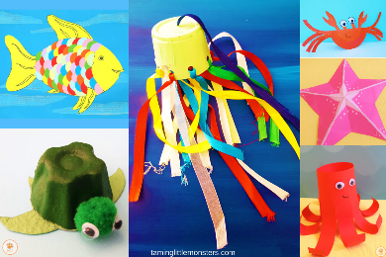
 | Music |  | Celebration Music | Exploring Sound | Music and Movement | Musical Stories | Big Band

